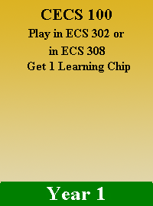

|  |  |
| --- | --- |
| User Stories | As a player I play the card CECS 100 to get 1 Learning Chip |
| Acceptance Criteria | Play in ECS 302 or in ECS 308 |

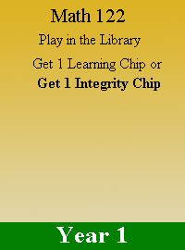

|  |  |
| --- | --- |
| User Stories | As a player I play the card MATH 122 to get 1 Learning Chip or 1 Integrity Chip |
| Acceptance Criteria | Play in the library |

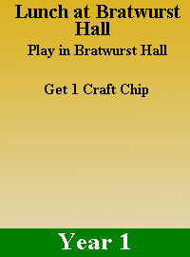

|  |  |
| --- | --- |
| User Stories | As a player I play the card Lunch at BratWurst Hall to get 1 Craft Chip |
| Acceptance Criteria | Play at BratWurst Hall |

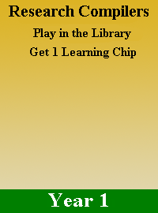

|  |  |
| --- | --- |
| User Stories | As a player i play the card Research Compilers card to get 1 Learning Chip |
| Acceptance Criteria | Play in the Library |

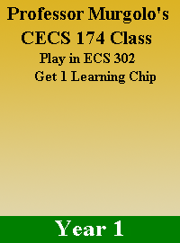

|  |  |
| --- | --- |
| User Stories | As a player I play the card Professor Murgolo’s CECS 174 class to get 1 Learning Chip |
| Acceptance Criteria | Must play in ECS 302 |



|  |  |
| --- | --- |
| User Stories | As a player I play CECS 100 card to get 1 Craft Token |
| Acceptance Criteria | Must play in ECS 308 |

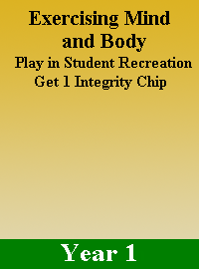

|  |  |
| --- | --- |
| User Stories | As a player I play the Exercising Mind and Body to get 1 Integrity Chip |
| Acceptance Criteria | Must play in the Student Recreation |

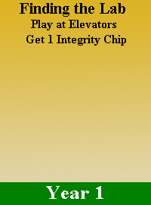

|  |  |
| --- | --- |
| User Stories | As a player I play the Finding the Lab card to get 1 Integrity Chip |
| Acceptance Criteria | Must play in the Elevators |

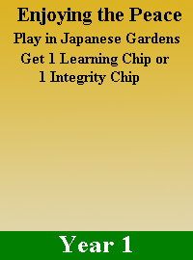

|  |  |
| --- | --- |
| User Stories | As a player I play the Enjoying the Peace card to get 1 Learning Chip or 1 Integrity Chip |
| Acceptance Criteria | Must play in the Japanese Gardens |

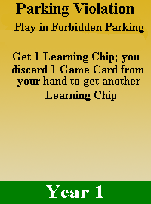

|  |  |
| --- | --- |
| User Stories | As a player I play the Parking Violation Card to get 1 Learning Chip and discard 1 Game Card from my hand to get another Learning Chip |
| Acceptance Criteria | Must play in the Forbidden Parking |

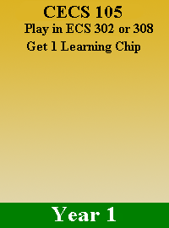

|  |  |
| --- | --- |
| User Stories | As a player I play the CECS 105 card to get 1 Learning chip |
| Acceptance Criteria | Must play in ECS 302 or 308 |

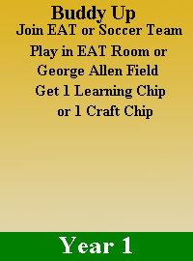

|  |  |
| --- | --- |
| User Stories | As a player I play the Buddy Up Join EAT or SOCCER TEAM to get 1 Learning Chip or 1 Craft Chip |
| Acceptance Criteria | Must play in EAT Room or George Allen Field |

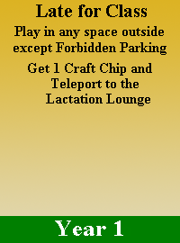

|  |  |
| --- | --- |
| User Stories | As a player I play the Late For Class to get 1 Craft Chip and Teleport to the Lactation Lounge |
| Acceptance Criteria | Must play in anyspace outside except Forbidden Parking |

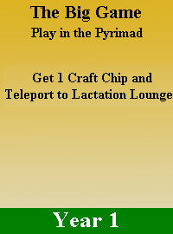

|  |  |
| --- | --- |
| User Stories | As a player I play the Big Game to get 1 Craft Chip and Teleport to Lactation Lounge |
| Acceptance Criteria | Play in the Pyramid |

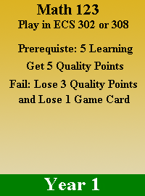

|  |  |
| --- | --- |
| User Stories | I play the Math 123 card to get 5 Quality Points |
| Acceptance Criteria | I play it in ECS 302 or 308  I got at least 5 Learning Points  If I fail any requirements above I lose 3 Quality Points and lose 1 Game Card |

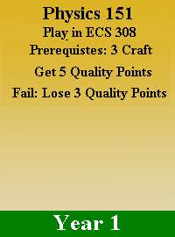

|  |  |
| --- | --- |
| User Stories | I play the PHYSIC 151 card to get 5 Quality Points |
| Acceptance Criteria | I play it in ECS 308  I got at least 3 Craft  If I fail any requirements above I lose 3 Quality Points |

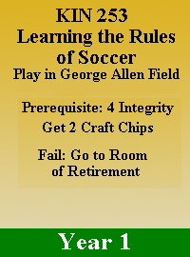

|  |  |
| --- | --- |
| User Stories | As a Player I play the KIN 253 Learning the Rules of Soccer Card to get 2 Craft Chips |
| Acceptance Criteria | I play it in George Allen Field  I got at least 4 Integrity  If I fail any requirements above I go to the room of Retirement |

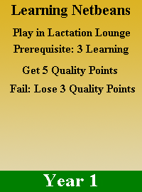

|  |  |
| --- | --- |
| User Stories | As a player I play the Learning Netbeans Card to get 5 Quality Points |
| Acceptance Criteria | I play it in Lactation Lounge  I got at least 5 Learning  If I fail any requirements above I lose 3 Quality Points |



|  |  |
| --- | --- |
| User Stories | As a player I play the Learning Linux Card to get 3 Quality Points and a Chip of my choice |
| Acceptance Criteria | I must play it in computer lab  I got at least 2 Craft and 3 Integrity  If I fail any requirements above I lose 1 Quality Point |

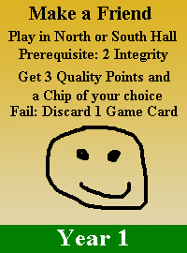

|  |  |
| --- | --- |
| User Stories | As a player I play Make a Friend card to get 3 Quality Points and a Chip of my choice |
| Acceptance Criteria | I play it in North or South Hall  I got at least 2 Integrity  If I fail any requirements above I discard 1 game card |

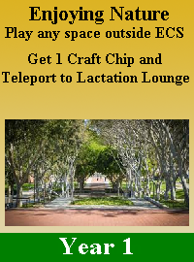

|  |  |
| --- | --- |
| User Stories | As a player I play the card Enjoying Nature card to get 1 Craft Chip and teleport to Lactation Lounge |
| Acceptance Criteria | I play it in any space outside ECS |

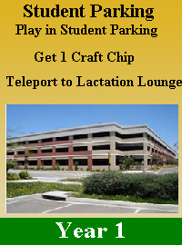

|  |  |
| --- | --- |
| User Stories | As a player I play the Student Parking card to get 1 Craft Chip and teleport to Lactation Lounge |
| Acceptance Criteria | I play it in Student Parking |

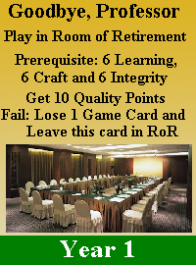

|  |  |
| --- | --- |
| User Stories | As a player I play the Goodbye, Professor card to get 10 Quality Points |
| Acceptance Criteria | I play it in Room of Retirement  I got at least 6 Learning, 6 Craft and 6 Integrity  If I fail any requirement above, I lose 1 game card and leave this card in RoR |

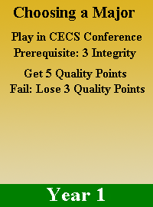

|  |  |
| --- | --- |
| User Stories | As a player play the Choose a Major card to get 5 Quality Points |
| Acceptance Criteria | I play it in CECS Conference  I got at least 3 Integrity  If I fail any requirements above I lose 3 Quality Points |

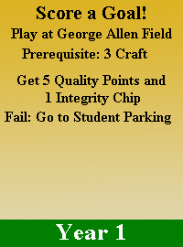

|  |  |
| --- | --- |
| User Stories | As a player play the Score a Goal! Card to get 5 Quality Points and 1 Integrity Chip |
| Acceptance Criteria | I play it at George Allen Field  I got at least 3 Craft  If I fail any requirements above I must go to Student Parking |

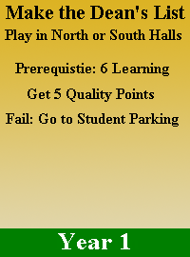

|  |  |
| --- | --- |
| User Stories | As a player I play the Make the Dean’s List to get 5 Quality Points |
| Acceptance Criteria | I play it in North or South Halls  I got at least 6 Learning  If a fail any requirements above i go to Student Parking |

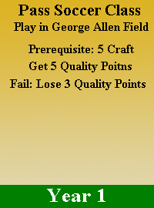

|  |  |
| --- | --- |
| User Stories | As a player I play the Pass Soccer Class card to get 5 Quality Points |
| Acceptance Criteria | I must play it in George Allen Field  I must have at least 5 Crafts  If I fail I will lose 3 Quality Points |

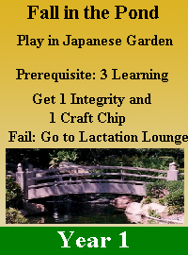

|  |  |
| --- | --- |
| User Stories | As a player I play the Fall in the Pond to get 1 Integrity and 1 Craft Chip |
| Acceptance Criteria | I must play it in the Japanese Garden  I must have at least 3 Learning  If I fail any requirements above I have to go to the Lactation Lounge |

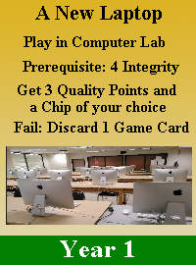

|  |  |
| --- | --- |
| User Stories | As a player I must play the A New Laptop card to get 3 Quality Points and a 1 chip of my choice |
| Acceptance Criteria | I must play it in computer lab  I must have at least 4 Integrity  If I fail any requirements above I must discard 1 game card |

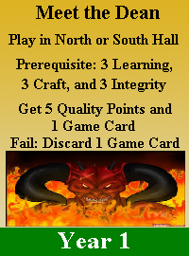

|  |  |
| --- | --- |
| User Stories | As a player I play the Meet the Dean card to get 5 quality points and 1 game card |
| Acceptance Criteria | I must play it in North or South Hall  I must have at least 3 Learning, 3 Craft, 3 Integrity  If I fail any requirements above I must discard 1 game card |

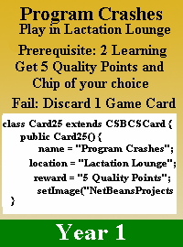

|  |  |
| --- | --- |
| User Stories | As a player I play the Program Crashes card to get 5 Quality Points and Chip of my choice |
| Acceptance Criteria | I must play it in Lactation Lounge  I must have at least 2 Learning  If I fail I must discard 1 game card |

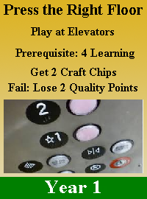

|  |  |
| --- | --- |
| User Stories | As a player I play the Press the Right Floor card to get 2 Craft Chips |
| Acceptance Criteria | I must play it at the Elevators  I must have at least 4 Learning  If I fail one of the requirements above I lose 2 quality points |

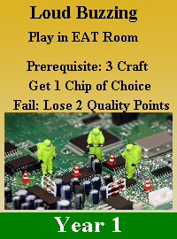

|  |  |
| --- | --- |
| User Stories | As a player I play the Loud Buzzing card to get 1 Chip of choice |
| Acceptance Criteria | I must play it in the EAT Room  I must have at least 3 Craft  If I fail any requirement above I will lose 2 Quality Points |

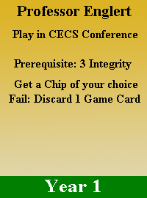

|  |  |
| --- | --- |
| User Stories | As a player I play the Professor Englert card to get a chip of my choice |
| Acceptance Criteria | I must play it in CECS Conference  I need at least 3 Integrity  If I fail I must discard 1 game card |

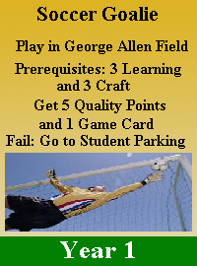

|  |  |
| --- | --- |
| User Stories | As a player I play the soccer Goalie to get 5 Quality Points and a game Card |
| Acceptance Criteria | Must play in George Allen Field  Must have at least 3 Learning, 3 Craft  If I fail any requirement above I must go to the Student Parking |